**Group Activity 1B; CS 3060**

**Names** of students in your group: Dylan S, Ethan T, Nicholas W, Nicholas B, Tyson S

Points: 5

**Task**: Assume that we have a file named data.txt, which contains information about different items, such as computer, board, pen, chair, desk, and so on. The first few lines of the file are as follows, but we do not know the exact number of items (i.e., the exact number of lines). Yet we know that the format of each line is similar.

Item does price($)

computer calculates 400

board holds 50

pen writes 1

chair supports 50

… add 2 or more lines in data.txt to test your program.

Write a Ruby program below, which will read the whole file and will report the following: (a) the number of items, (b) price of “desk”, and (c) name of the costliest item.

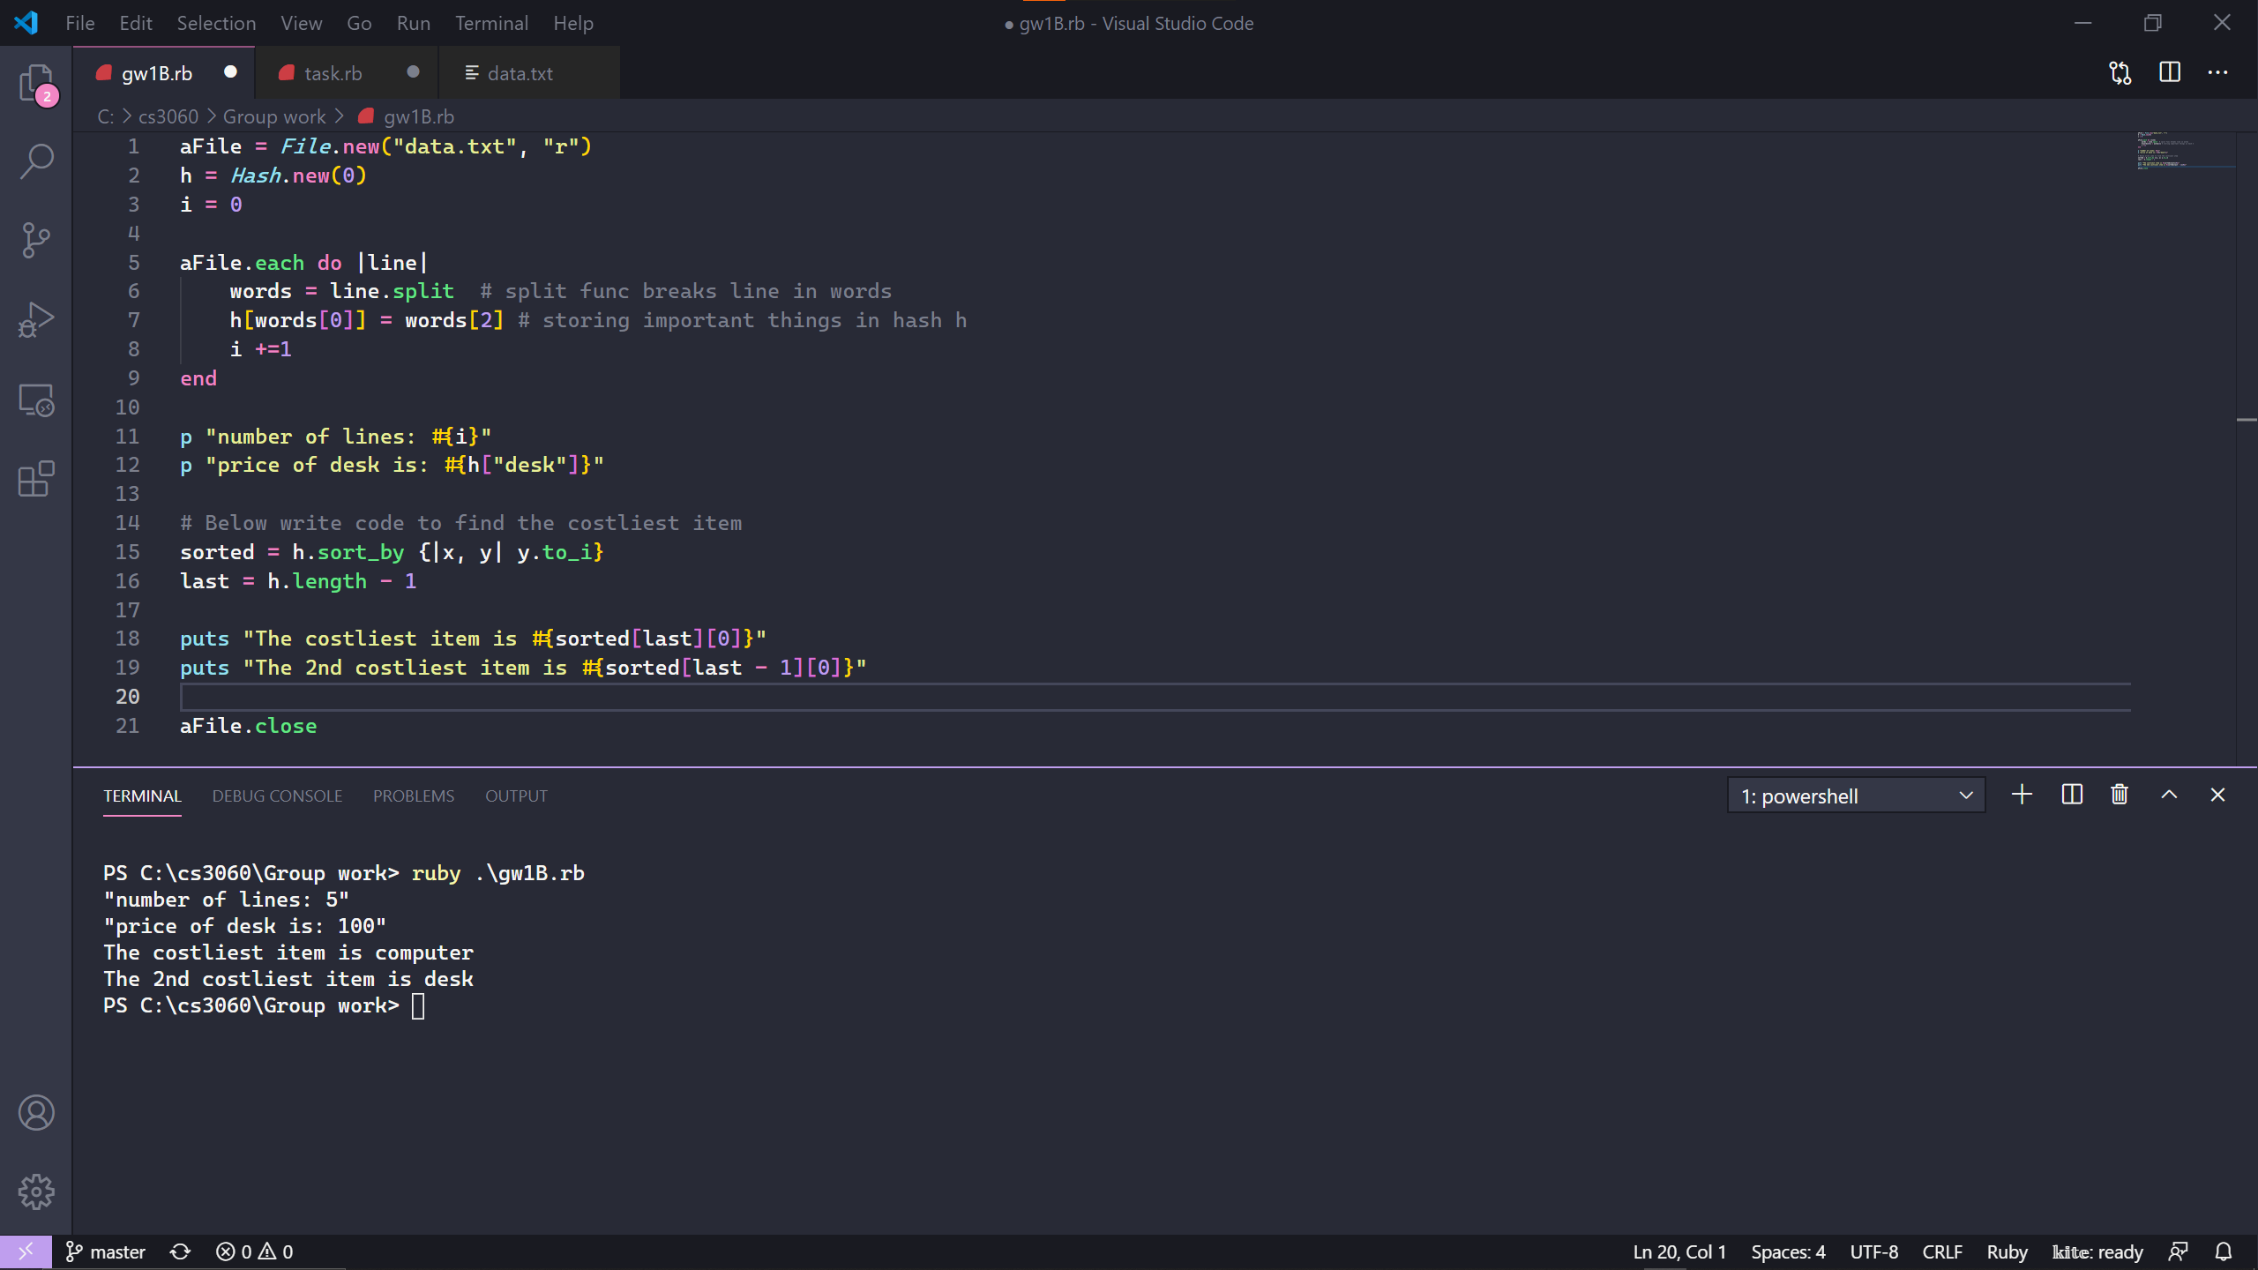

Bonus problem (1 point): Extend your code to find (and report) the second-costliest item’s name.

**Submit** this word file (after completion) and a screenshot of output (of running the code) to Canvas.